#### SRI KRISHNA COLLEGE OF TECHNOLOGY

**An Autonomous Institution | Accredited by NAAC with 'A' Grade Affiliated to Anna University | Approved by AICTE**

**KOVAIPUDUR, COIMBATORE 641042**

### COFFEE SHOP

#### A PROJECT REPORT

***Submitted by***

#### SHREYAS PP 727822TUCS217

***in partial fulfillment for the award of the degree*** ***of***

#### BACHELOR OF ENGINEERING IN

**DEPARTMENT OF COMPUTER SCIENCE AND ENGINEERING**

#### JANUARY 2023

**SRI KRISHNA COLLEGE OF TECHNOLOGY**

**An Autonomous Institution | Accredited by NAAC with 'A' Grade Affiliated to Anna University | Approved by AICTE**

#### KOVAIPUDUR, COIMBATORE 641042

**BONAFIDE CERTIFICATE**

Certified that this project report **“COFFEE SHOP”** is the bonafide work of

**“SHREYAS(727822TUCS217)”** who carried out the project work under my supervision.

**SIGNATURE SIGNATURE**

**Mr. V. VENKATESH Dr. R. VIDHYA**

**SUPERVISOR HEAD OF THE DEPARTMENT**

Assistant Professor, Professor,

Department of Computer Science Department of Computer Science

and Engineering and Engineering

Sri Krishna College of Technology, Sri Krishna College of Technology,

Coimbatore-641042. Coimbatore-641042.

Certified that the candidates were examined by us in the Project Work Viva Voce examination held on at Sri Krishna College of Technology, Kovaipudur, Coimbatore -641042

#### INTERNAL EXAMINER EXTERNAL EXAMINER

***ACKNOWLEDGEMENT***

#### ACKNOWLEDGEMENT

First and foremost, we thank the **Almighty** for being our light and for showering his gracious blessings throughout the course of this project.

We are grateful to our beloved Dean-Academics **Dr.Manju P &** Dean-Administration **Dr.R.Ramesh Kumar** for their tireless and relentless support.

We extend our sincere thanks to our Head of the Department

**Dr. R. Vidhya** for her encouragement and inspiration.

We are greatly indebted to our Industry Mentor **Ms. Fred** and **Ms. Seema** & Project guide **Mr. V. VENKATESH** Assistant Professor, Department of Computer Science and Engineering for their valuable guidance and suggestions in all aspects that aided us to ameliorate our skills.

We are thankful to all those who have directly and indirectly extended their help to us in completing this project work successfully.

***ABSTRACT***



## ABSTRACT

### An online cafe shop is a virtual platform that offers cafe products and services online. Customers can order food and drinks, make payments, and have their orders delivered to their doorstep or pick them up at a designated location. Online cafe shops may offer a wide range of products, including coffee, tea, pastries, sandwiches, and other snacks. They provide a convenient way for customers to order their favorite cafe items without leaving their home or office.

# TABLE OF CONTENTS



**TABLE OF CONTENT**

|  |  |  |
| --- | --- | --- |
| **CHAPTER.NO** | **TITLE** | **PAGE NO** |
| 1 | INTRODUCTION | 1 |
|  | 1.1 PROBLEM STATEMENT | 2 |
|  | 1.2 OVERVIEW | 2 |
|  | 1.3 OBJECTIVE | 2 |
| 2 | SYSTEM SPECIFICATIONS | 5 |
| 3 | PROPOSED SYSTEM | 8 |
|  | 3.1 PROPOSED SYSTEM | 8 |
|  | 3.2 ADVANTAGES | 9 |
| 4 | METHODOLOGIES | 10 |
|  | 4.1 LOGIN PAGE | 11 |
|  | 4.3 SIGNUP PAGE | 13 |
|  | 4.4 MENU PAGE | 13 |
|  | 4.5 CONTACT PAGE | 14 |
| 5 | IMPLEMENTATION AND RESULT | 15 |
| 6 | CONCLUSION AND FUTURE SCOPE | 36 |
|  | 6.1 CONCLUSION | 36 |
|  | 6.2 FUTURE SCOPE | 37 |
| 7 | REFERENCES | 38 |

# LIST OF FIGURES



vi

**LIST OF FIGURES**

|  |  |  |
| --- | --- | --- |
| **Figure No** | **TITLE** | **Page No** |
| 4.1 | Process flow diagram | 10 |
| 4.2 | Login page flowchart | 11 |
| 5.1 | Login page | 15 |
| 5.2 | Sign up page | 17 |
| 5.3 | Home page | 19 |
| 5.4 | Menu page | 55 |
| 5.5 | Contact page | 65 |

# LIST OF ABBREVIATIONS



vii

**LIST OF ABBREVIATIONS**

#### ABBREVIATIONS

**ACRONYMS**

**HTML** HYPERTEXT MARKUP LANGUAGE

**CSS** CASCADING STYLESHEET

**JS** JAVASCRIPT

# INTRODUCTION



**CHAPTER 1 INTRODUCTION**

This project gives the solution to students and faculties of Sri Krishna College of Technology who are spending much time to get their breakfast, lunch from the hotels. In this chapter we are going to see what is the problem statement, overview and the main objective of this project.

* 1. **PROBLEM STATEMENT**

How can we create a website that allows students and faculties to order their breakfast and lunch using their register number and email id’s password as their credential?

### OVERVIEW

In the hotels of Sri krishna college of Technology there will be lot of persons are standing in the queue in order to get their breakfast and lunch for that they will spend a lot of time. To avoid this kind of issue, we developed a website where students and faculties will order their breakfast and lunch and they can pay the amount by online payment.

### OBJECTIVE

The main objective is to provide a solution to the students and faculties of Sri Krishna College of Technology to save their time by not standing in a queue to get their breakfast and lunch.

# SYSTEM SPECIFICATION



**CHAPTER 2 SYSTEM SPECIFICATION**

In this chapter, we are gonna see the softwares that we have used to build the website. This chapter gives you a small description about the softwares used in the project.

* 1. **VS CODE**

Visual Studio Code is a source code editor developed by Microsoft for Windows, Linux, and macOS. It includes support for debugging, embedded Git control, syntax highlighting, intelligent code completion, snippets, and code refactoring. It is also customizable, so users can change the editor's theme, keyboard shortcuts, and preferences.

VS Code is an excellent code editor for React projects. It is lightweight, customizable, and has a wide range of features that make it ideal for React development. It has built-in support for JavaScript, JSX, and TypeScript, and enables developers to quickly move between files and view detailed type definitions. It also has a built-in terminal for running tasks. Additionally, VS Code has an extensive library of extensions that allow developers to quickly add features like code snippets, debugging tools, and linting support to their projects.

### LOCAL STORAGE

Local storage is a type of web storage for storing data on the client side of a web browser. It allows websites to store data on a user’s computer, which can then be accessed by the website again when the user returns. Local storage is a more secure alternative to cookies because it allows websites to store data without having to send it back and forth with each request. Local storage is a key-value pair storage mechanism, meaning it stores data in the form of a key and corresponding value. It is similar to a database table in that it stores data in columns and rows, except that local storage stores the data in the browser rather than in a database. Local storage is often used to store user information such as

preferences and settings, or to store data that is not meant to be shared with other websites. It is also used to cache data to improve the performance of a website. Local storage is supported by all modern web browsers, including Chrome,

Firefox, Safari, and Edge. It is accessible through the browser’s JavaScript API. Local storage is a powerful tool for websites to store data on the client side. It is secure, efficient, and can be used to store data that does not need to be shared with other websites.

Local Storage is a great way to improve the performance of a website by caching data. Local storage in web browsers allows website data to be stored locally on the user’s computer. It is a way of persistently storing data on the client side, which is not sent to the server with each request. This allows users to store data such as preferences, login information, and form data without needing to send it to a server. It is typically stored in a browser’s cookie file, but it can also be stored in other locations such as HTML5 Local Storage and IndexedDB. The data stored in local storage is persistent and can be accessed by the website even if the user closes the browser or navigates to another page. It is a great way for websites to store user-specific data, as it is secure, reliable, and fast. It is also a great way for developers to store data that does not need to be sent to the server with each request.

One of the key benefits of using local storage is its reliability. Unlike server-side storage, which can be affected by network outages or other server issues, local storage is stored locally on the user’s machine, and so is not affected by these issues. Another advantage of local storage is its speed. Because the data is stored locally, it is accessed quickly, as there is no need to send requests to a server. This makes it ideal for storing data that needs to be accessed quickly, such as user preferences or session data. Local storage is also secure, as the data is stored on the user’s machine and not on a server. Thismeans that the data is not accessible by anyone other than the user, making it a good choice for storing sensitive information.

# PROPOSED SYSTEM



## CHAPTER 3 PROPOSED SYSTEM

This chapter gives a small description about the proposed idea behind the development of our website

* 1. **PROPOSED SYSTEM**

This E-commerce: Customers can browse the coffee shop's products, such as coffee beans, ground coffee, and coffee accessories, and make purchases online. This allows the coffee shop to reach a wider audience and increase its revenue.

Online ordering: Customers can order coffee and other beverages, as well as food items, online and have them delivered to their home or office. This can provide added convenience to customers and increase the coffee shop's sales.

Loyalty program: The coffee shop can implement a loyalty program that rewards customers for their purchases and encourages repeat business.

Social media integration: The coffee shop can integrate its online site with social media platforms to promote its products, events, and promotions to a larger audience.

Customer feedback system: The online site can provide a way for customers to leave feedback on their experience, which can be used to improve the coffee shop's offerings and services.

.

### ADVANTAGES

* Time-saving: Customers can save time by avoiding long lines at physical cafes or restaurants.
* Access to a wide range of products: Online cafe shops often have a larger menu selection than physical cafes, with more food and drink options to choose from.
* 24/7 availability: Online cafe shops are usually open 24/7, which means customers can order at any time of the day or night.
* Delivery options: Many online cafe shops offer delivery services, which can be a convenient option for customers who don't have the time or ability to pick up their orders.
* Competitive prices: Online cafe shops may offer lower prices than physical cafes due to lower overhead costs.
* Virtual events and classes: Some online cafe shops offer virtual events and classes, such as coffee tasting sessions and barista training, which can be a fun and educational experience for customers. ·Convenience: Customers can order their favorite cafe items from the comfort of their own home or office.
* Time-saving: Customers can save time by avoiding long lines at physical cafes or restaurants.
* Access to a wide range of products: Online cafe shops often have a larger menu selection than physical cafes, with more food and drink options to choose from.
* 24/7 availability: Online cafe shops are usually open 24/7, which means customers can order at any time of the day or night.
* Delivery options: Many online cafe shops offer delivery services, which can be a convenient option for customers who don't have the time or ability to pick up their orders.
* Competitive prices: Online cafe shops may offer lower prices than physical cafes due to lower overhead costs.
* Virtual events and classes: Some online cafe shops offer virtual events and classes, such as coffee tasting sessions and barista training, which can be a fun and educational experience for customers.

# METHODOLOGIES



**CHAPTER 4 METHODOLOGIES**

This chapter gives a small description about how our system works.

**Sign up**

**Login**

**Home**



**Shop-4**

**Shop-3**

**Shop-2**

**Shop-1**

**Menu**

|  |  |
| --- | --- |
| Fig 4.1. | Process flow diagram |

**4.1.LOGIN**

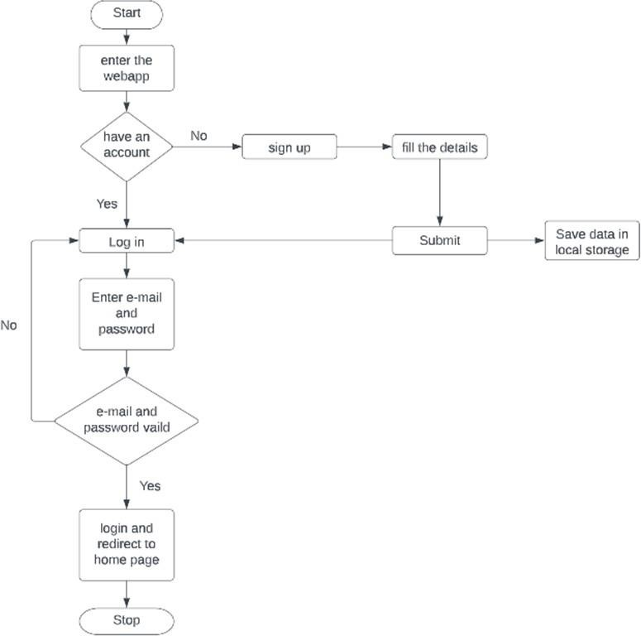

Fig 4.2. LOGIN PAGE FLOWCHART

In this page we will be asking about the username and password of the user. Firstly the website validates the user inputs. It verifies the username and password by checking it with the usernames and passwords stored in the local storage when the user creates an account in the website.

# IMPLEMENTATION AND RESULT



**CHAPTER 5 IMPLEMENTATION AND RESULT**

This chapter gives a description about the output that we produced by developing the website of our idea.

* 1. **LOGIN**

When User enters our website he will be asked about his login details like email id and password. The login details will be verified with the details given while the user creates an account.

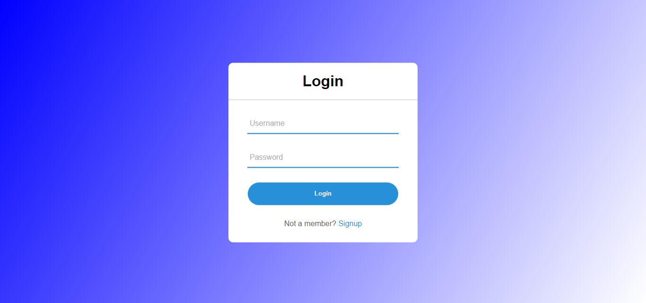

Fig 5.1 LOGIN PAGE

### SIGN UP PAGE

If the user does not have an existing account, they must create a new account to access all the feature in the website. For creating an account the user must provide the email, contact number, and they should also create a new password for the account as well.

.

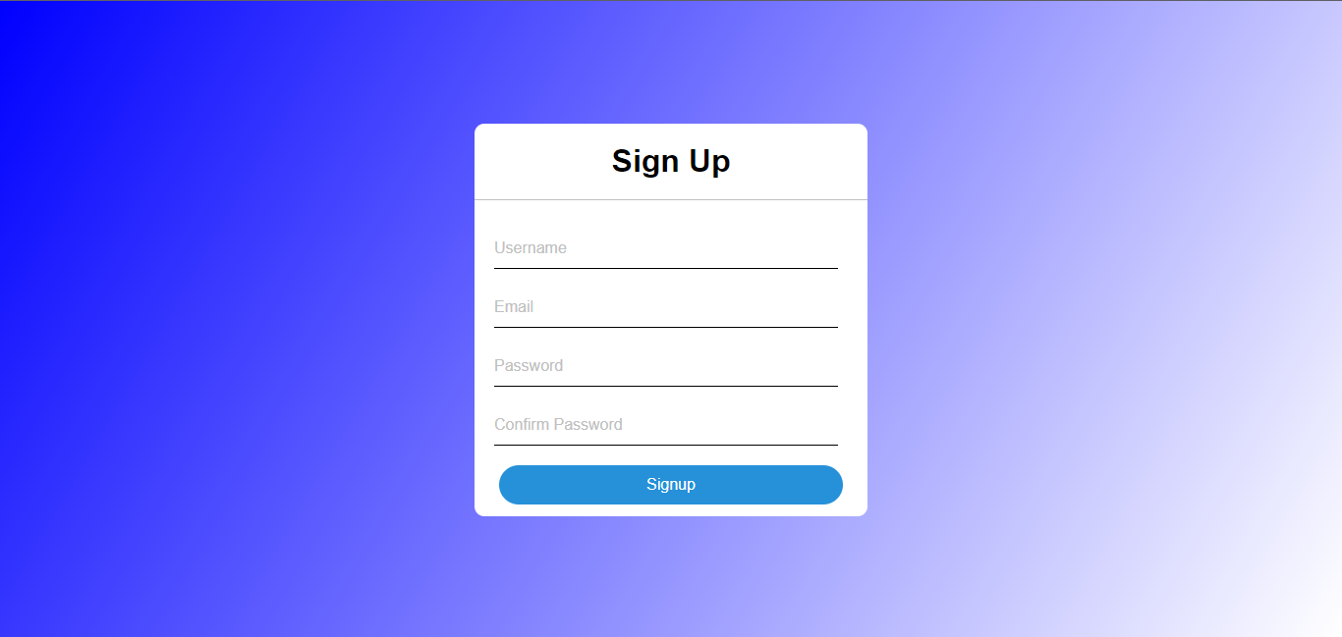

Fig 5.2 SIGN UP PAGE

### MENU PAGE

The webpage shows all the details regarding the prices of the snacks, the customers can select the required items they want.

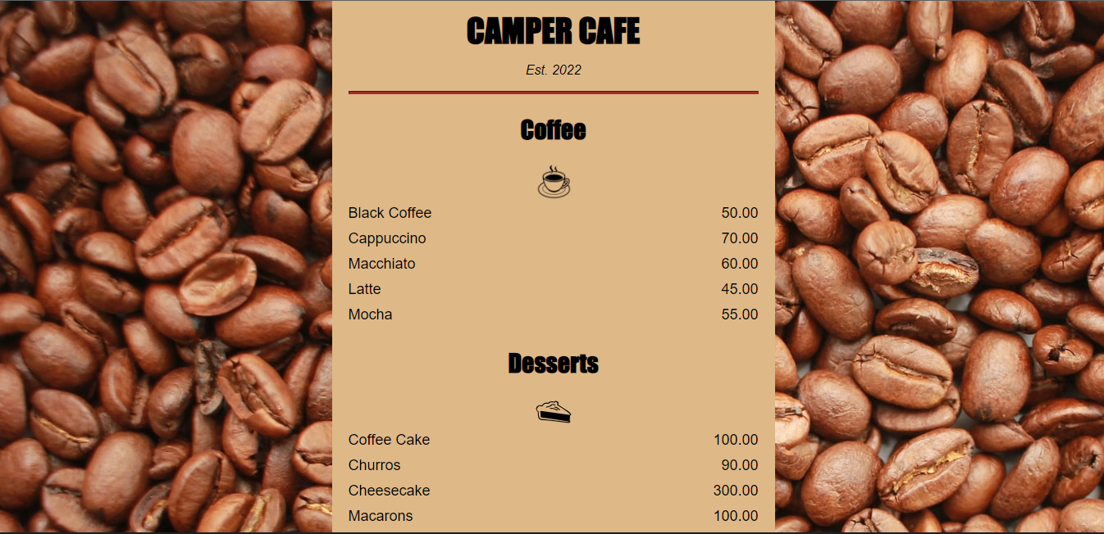

Fig 5.3 HOME PAGE

### HOME PAGE

This page displays the list of items available for ordering.

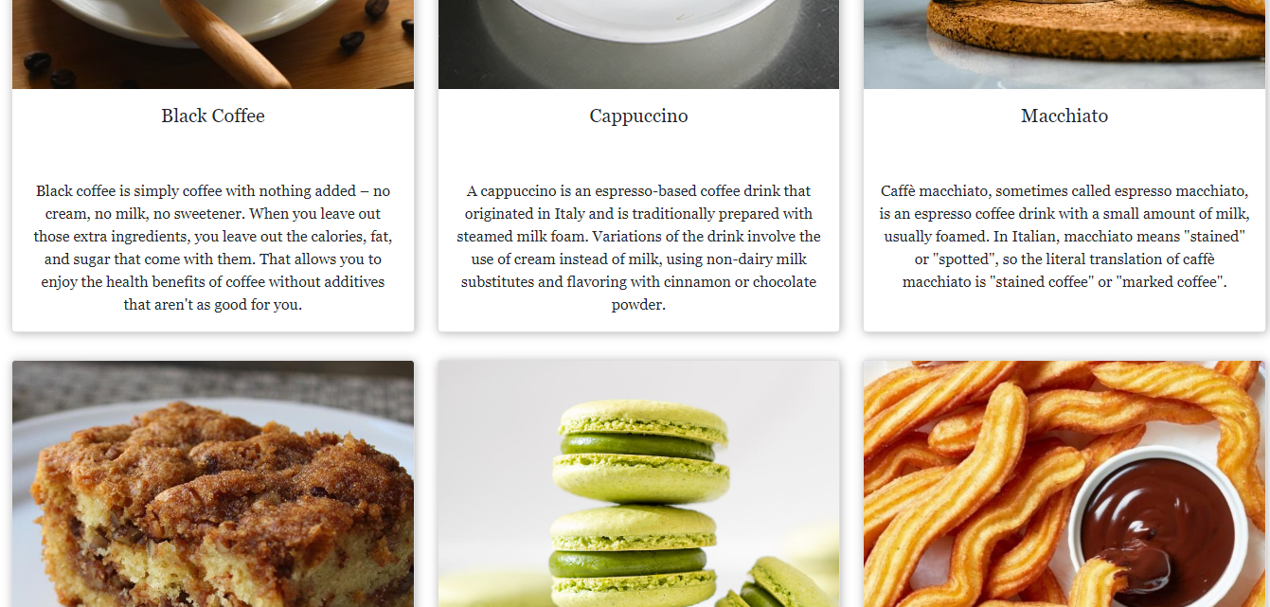

Fig 5.4 HOME PAGE

### CONTACT PAGE

This A contact us page on a website is webpage that provides visitors with information on how to get in touch with the website’s owner or operator. It serves as a point of contact between the website and its customers.

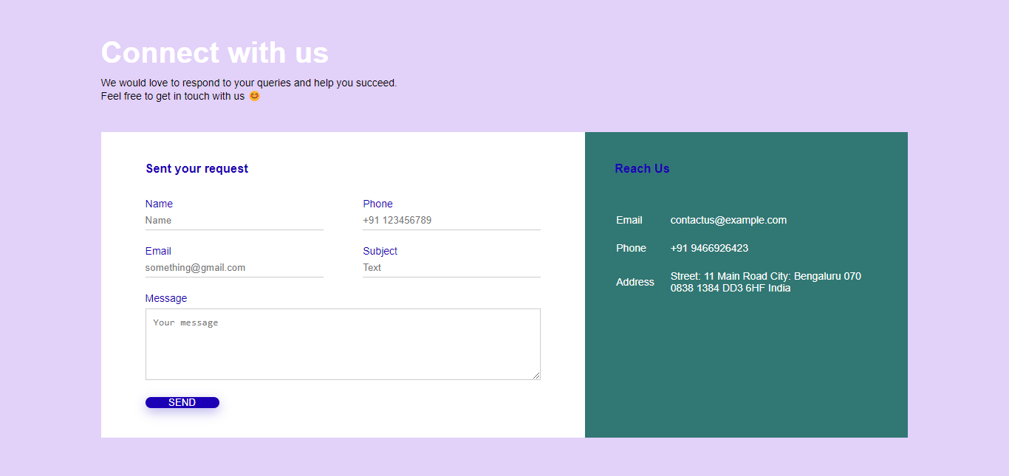

Fig 5.5 CONTACT PAGE

### CODING

#### Login:

# CONCLUSION



## CHAPTER 6 CONCLUSION

This chapter tells about the conclusion that anyone can drive from the project and the learning we learnt by taking over this project.

* 1. **CONCLUSION**

In conclusion an online food ordering system is proposed which is useful in small family run restaurants as well as in places like college cafeteria, etc. This project can later be expanded on a larger scale. It is developed for restaurants to simplify their routine managerial and operational task and to improve the dining experience of the clients. This also helps the restaurant owners develop healthy customer relationships by providing reasonably good services. The system also enables the restaurant to know the items available in real time and make changes to their food and beverage inventory based on the orders.

### FUTURE SCOPE

#### Drive Sales with Social Media

The popularity of smartphones and the usage of social media platforms using smartphones is known to the world. So, it must not be a surprise that food chains are now including provisions of using their mobile application for ordering to promote their sales.

Food chains like Domino’s and Pizza Hut even have the provision to create a profile for customers where their contact info and preferring to store the pizza menu. Hence, customers can order a pizza using their smartphone by texting emojis. What can be easier than this? What does it mean to be successful on social media?

Focus on what matters to your restaurant brand. As a restaurant owner, you need to understand the ROI of your social presence. You need to get more orders and traffic into your food business. That’s the bottom line. Let’s take a look at how to use social media to boost sales for your restaurant.

#### Mobility and Ease

With the online mobile payment feature ordering food using restaurant based apps has become easier these days. There occurs no requirement to make use of cash. One can order food online using online payment modes right from the restaurant ordering app.

Customers can also save up payment-related information in their profiles. Hence, ordering repeatedly is hassle-free; there is no need to add their account details, again and again. With a single button, one can order food online!

#### Phone Orders Outstripped

The ease and convenience of online food ordering using restaurant mobile apps make sure that Tele calling is no longer used for ordering. The reason behind this is the user-friendly interface of the food ordering app provides a smooth ordering experience to customers.

While placing orders, customers can select their preferred order type; if it’s a takeaway or a home delivery. Next, the food ordering app prompts customers to choose their location with an easy drop-down button. It allows customers to select their city and the local outlet before they proceed to the menu and place their order.

Hence there is no potential chance of a communication mishap. The restaurant mobile apps use the Translation system, and hence, language is no longer a problem.

#### Home Deliveries Increased

The more the population is increasing with their increased purchasing power, the more are the situations of online food ordering occurring. Home deliveries are a matter of daily system nowadays for every restaurant, big or small in the town.

In areas where the population is dense customers prefer having food within the comforts of their home. Provisions of home delivery increase sales. The online ordering system using apps also access this feature.

#### Food Pre-Ordering Using Restaurant App

There is a feature called ‘Advance Order’ or ‘Food Pre-Ordering’ which allows users to schedule their order’s delivery time. With the help of the [**food pre-ordering feature**,](https://www.restroapp.com/blog/restaurant-app-features-food-pre-orders/) customers get the freedom of choosing delivery or pickup time, at the time of placing their orders. Customers can

select their usual order to be delivered immediately or set a particular time for future delivery. The restaurant is immediately notified about your customers’ preferred schedule.

Restaurant food Pre-orders have gained substantial traction in the market. Worldwide, the food delivery market stands at $93 billion, that’s 1% of the total food market. The annual growth for this space is estimated to be 3.5% for the next five years as per McKinsey.

#### Price Drops

More and more restaurants are using mobile platforms for food ordering. This means competitiveness is high in the market. As a result, the price of food gets lowered, and it is a blessing for the customers.

One engages customers online, offers promotions, rebates, and discounts, and these make sure your customer is loyal to the brand. Using restaurant management data analytics, entrepreneurs now can know a lot about the ordering trend of customers.

Food ordering over a smartphone using a mobile app is going to see a boom in the year 2016. Ordering things online will be the second habit of individuals. If we speak about more futuristic ways of delivery of food, then we must talk about something called the driverless delivery of food.

# REFERENCES



### REFERENCES

* + 1. GeeksforGeeks, “Types of E- commerce”, [https://www.geeksforgeeks.org/types-of-e-](https://www.geeksforgeeks.org/types-of-e-commerce/) [commerce/](https://www.geeksforgeeks.org/types-of-e-commerce/)
    2. Shopify, “How to Create a Custom PC Building Website”,[https://www.shopify.ca/blog/custom-pc-building-](https://www.shopify.ca/blog/custom-pc-building-website)

[website](https://www.shopify.ca/blog/custom-pc-building-website)

* + 1. Smashing Magazine, “Designing For E- Commerce”,[https://www.smashingmagazine.com/2016/11/designing-](https://www.smashingmagazine.com/2016/11/designing-for-e-commerce/) [for-e-commerce/](https://www.smashingmagazine.com/2016/11/designing-for-e-commerce/)
    2. TutsPlus, “How to Create an Ecommerce Website with WordPress andWooCommerce”,

https://webdesign.tutsplus.com/tutorials/how-to-create-an-ecommerce-web site-with-wordpress-and-woocommerce--cms-31938